**Topics: Class, Object and Function**

**Duration: 60 min (Start: 1:30, End: 2:30, Submission: 2:35)**

**Marks: 12+6+2 = 20**

1. Write a Credit Card class in python. A user can cash out (debit) money or pay shopping bills from his/her own card based on availability or limit. Initially, a credit card holder gets 100000 taka limit. The user has to pay back to the credit card bank. **[12]**

Moreover, the account stores the following information

Instance variables: (information should be provided at the time of account creation)

* 1. Name of the credit card holder
  2. Credit card number
  3. Current Balance
  4. Max limit

Methods:

1. Deposit
2. Debit
3. Show current balance
4. Pay bill

2. Write a python class for calculating the motion of a moving object by using the following equations **[6]**

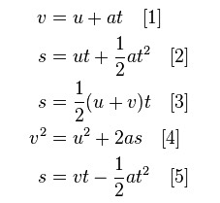

Coding test guidelines: **[2]**

1. Open a new file in google colab. Name of the file: A1_CT_4_ID

2. Share the file with me ([tsr@uap-bd.edu](https://mail.google.com/mail/?view=cm&fs=1&to=tsr%40uap-bd.edu&authuser=0))

3. Make sure your webcam is on during the test. (let me know if you have any problem, I will provide another question set)

4. Submit in the classroom properly. (from google drive)